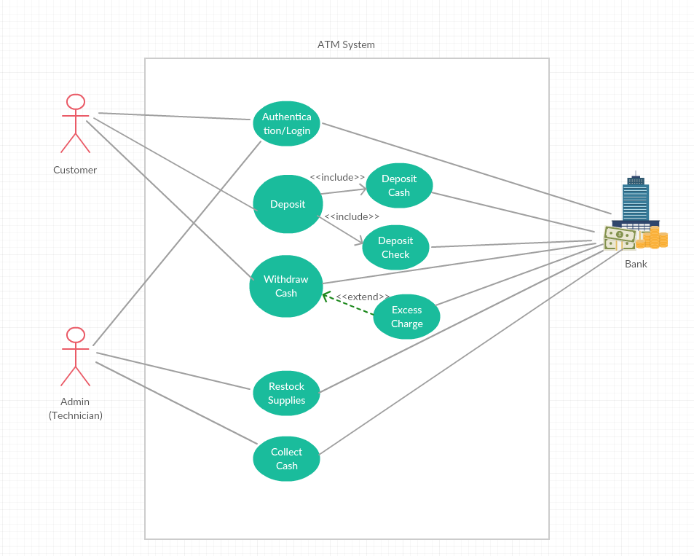

**ATM Use Case Diagram**

**(Answers to questions 1-4)**

**ATM System: Withdraw Cash Use Case Specification**

**(Draft Version 1 – 9/30/15)**

**1. Use Case Name – Withdraw cash**

Customer shall withdraw cash from the ATM from his or her account.

**2. Actors**

2.1 Customer

2.2 Bank

2.3 Admin (technician)

**3. Priority**

Must have, very important

**4. Status**

Requirements phase of Development

**5. Pre-conditions**

5.1 Authentication ends successfully: Customer validated

5.2 Money needs to already be in the system

5.3 Network needs to be available

**6. Post-conditions**

6.1 Successful Completion

Transaction has been logged; user has received the cash/card.

6.2 Failure Condition

The logs have been updated accordingly.

**7. Extension points**

Use case: Excess fee

**8. “Used” use cases**

N/A

**9. Basic Flow of Events**

9.1. The use case begins when Customer inserts Bank Card.

9.2. Customer inputs PIN.

9.3. Use Case: Authentication is performed.

9.4. The ATM displays the different options (2 options) that are available on this unit: Withdraw, Deposit. In this case the customer selects "Withdraw Cash".

9.5. The Bank Customer selects an account.

9.6. The ATM prompts for an amount.

9.7. The Customer enters an amount.

9.8 Card ID, PIN, amount and account is sent to Bank as a transaction. The Bank replies with a go/no go reply telling if the transaction is ok.

9.9. Then money is dispensed.

9.10. The Bank Card is returned.

9.11. The receipt is printed.

9.12. The use case ends successfully.

**10. Alternative flow**

10.1 Invalid User (wrong pin)

If in step 9.3 of the basic flow Bank Customer the use case: Validate User does not complete this successfully, then use case ends with a failure condition.

10.2 Amount Exceeds Withdrawal Limit (Withdraw limit)

If in step 9.7 in the basic flow, the Customer enters an amount that exceeds the withdrawal limit, then the ATM shall display a warning message, and ask the Bank Customer to reenter the amount. The use case resumes at step 9.7.

10.3 Insufficient Cash (insufficient funds)

If in step 7 in the basic flow, the Bank Customer enters an amount that exceeds the amount of cash available in the ATM, then the ATM will display a warning message, and ask the Bank Customer to reenter the amount. The use case resumes at step 9.7.

10.4 No Response from Bank (Timeout phase)

If in step 9. 8 of the basic there is no response from the Bank within 3 seconds, then

1. The ATM will re-try, up to three times.

2. If there is still no response from the Bank, the ATM shall display the message "Network unavailable – try again later".

3. The ATM shall return the card.

4. The ATM shall indicate that it is "Closed".

5. The use case ends with a failure condition.

10.5 Money Not Removed

If in step 9.9 of the basic flow the money is not removed from the machine within 15 seconds, then:

1. the ATM shall issue a warning sound and display the message "Please remove cash".

2. If there is still no response from the Bank Customer within 15 seconds the ATM will re-tract the money and note the failure in the log.

3. the use case end with a failure condition.

10.6 Excess Charge

If at point 9.5, customer was identified that he/she is from another bank, upon selection the account, the following steps to be performed:

1. Use case: Excess charge to be executed.

2. Customer continue to 9.6 or Cancel the transaction (see Quit flow below)

10.7 Quit

If at point prior to step 9.8 in the basic flow the Customer selects Quit, then

1. The ATM shall print a receipt indicating the transaction was cancelled.

2. The ATM shall return the card.

3. The use case ends.